**Regression Analysis on the influence of housing remodeling on property price**

**Team 3: Siyu Guo 7828852830**

**Yimei Li 2953761852**

**Yue Wang 6518654426**

**Mingfei Yu 7677774654**

**Mengying Zeng 2867561783**

**Huijuan Zhao 9173976898**

**University of Southern California**

Table of Contents

**1 Introduction3**

1.1 Remodeling3

1.2 Objects of Study3

1.3 Real Estate in California4

1.4 Purpose of Report7

1.5 Methodology7

**2 Literature Review8**

**3 Regression Analysis12**

3.1 Data Resources12

3.2 Descriptive Analysis15

3.3 Graphic Analysis17

3.4 Regression Analysis19

**4 Suggestions26**

4.1 Suggestions for government26

4.2 Suggestions for home buyers27

4.3 Suggestions for home sellers28

**5 Conclusion28**

**References30**

Regression Analysis on the influence of housing remodeling on property price

**1 Introduction**

**1.1 Remodeling**

Broadly speaking, remodeling refers to any kind of change to an existing property. More specifically, it means to change the character of a house or a portion of a house. For instance, a very popular type of remodeling is to combine the dining room and the kitchen that were originally designed to be two separate rooms into one large kitchen where you could both cook and eat.

Because remodeling changes the layout and characteristics of a house in accordance with residents’ preferences, it increases people’s satisfaction and usually sells at a higher price.

**1.2 Objects of study**

Our report selects two neighborhoods as the objects of study, namely Bel Air and Malibu.

**1.2.1 Bel Air**

Bel Air is an affluent neighborhood located in Westside Los Angeles, California.

The neighborhood is the site of four private and two public pre-collegiate schools. Founded in 1923, the Bel Air neighborhood has no multifamily dwellings and has been the filming location for many television shows.

**1.2.2 Malibu**

Malibu, another affluent beach city located in Los Angeles County, California, consists of a 21-mile strip of prime Pacific coastline. The neighborhood is famous for the warm, sandy beaches, and for being the home of many Hollywood movie stars. This region experiences warm and dry summer, and the average monthly temperatures do not exceed 71.6 °F.

**1.3 Real estate in California**

Urban housing markets are becoming increasingly significant in shaping the economic and social well-being of many Americans. A substantial variation exists across neighborhoods in the type of housing available, the quality of public services, the level of tax burdens, and the quality of life generally. Consequently, households confront important tradeoffs between different types of housing, neighborhood characteristics, and accessibility to work place. Since housing expenditures are a large component of every household's budget, the availability of housing and its price assume considerable importance. Moreover, housing markets play a central role in the process of metropolitan development, both affecting and reflecting other forces at work in this sphere. Urban development patterns, in turn, are crucial to our future welfare in many ways.

Living in decent, affordable, and reasonably located housing is one of the most important determinants of well-being for every Californian. More than just basic shelter, housing affects our lives in other important ways, determining our access to work, education, recreation, and shopping. The cost and availability of housing also matters for the state’s economy, affecting the ability of businesses and other employers to hire and retain qualified workers and influencing their decisions about whether to locate, expand, or remain in California.

Unfortunately, housing in California has long been more expensive than most of the rest of the country. Beginning in about 1970, however, the gap between California’s home prices and those in the rest country started to widen. Between 1970 and 1980, California home prices went from 30 percent above U.S. levels to more than 80 percent higher. This trend has continued. Today, an average California home costs $440,000, about two-and-a-half times the average national home price ($180,000). Also, California’s average monthly rent is about $1,240, 50 percent higher than the rest of the country ($840 per month). Many households struggle to find housing that is affordable and meets their needs. Amid this challenge, many households make serious trade-offs in order to live here. Because of the important role housing plays in the lives of Californians, the state’s high housing costs are a major ongoing concern for state and local policy makers.

As shown in graph 1, the average home prices in Malibu fluctuate a lot in the past 10 years. After a peak in 2007, the price quickly dropped and reached 2 million US dollars in 2012. In the following years, as the entire economy recovers from the global financial crisis, the prices started to increase, and this trend is very likely to continue in the future.

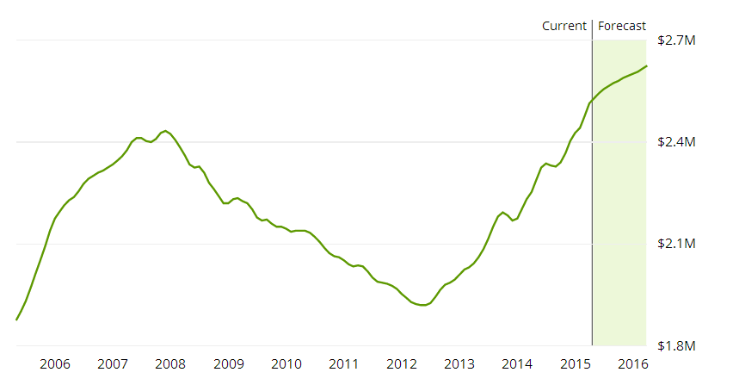

Graph 1: Past and forecasted home prices in Malibu

Graph 2 shows how home prices in Bel Air change in the past 10 years. There is also a drop in property prices after 2007, and it was not until 2012 did price gradually increase. The prices in Bel Air increased at a much lower rate than that in Malibu.

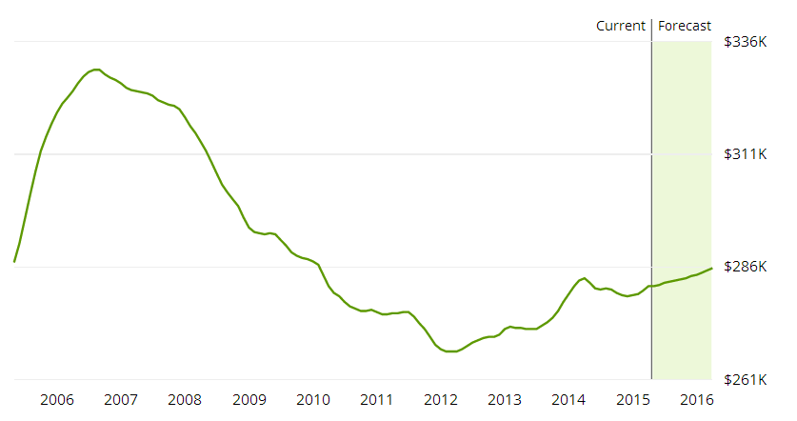

Graph 2: Past and forecast home prices in Bel air

**1.4 Purpose of report**

The purpose of this report is to study whether remodeling is a significant factor in determining property prices, and if it is significant, is remodeling increasing or decreasing property prices? And in what magnitude does remodeling change property prices.

Intuition tells us that remodeling is a significant factor in determining property prices, and will increase prices. To be more specific, given that remodeling not only changes the character and layout of a house according to people’s preferences, but also renovates houses if remodeling happens many years after when a house was originally built, a house that is remodeled tends to be sold at a higher price.

**1.5 Methodology**

This report uses multivariate regression analysis and hedonic pricing theory to analyze remodeling effects. More specifically, by regressing logarithm of property prices on such independent variables as number of bedrooms, number of bathrooms, square footage, year built, whether being remodeled, whether being remodeled in the past ten years, year built, etc., we are able to find out the exact relation between remodeling and home prices.

A model is a simplified representation of a real world phenomenon. The purpose of using a model is to test relationships among the constituent parts of the process, or to use as a means of making predictions.

Multivariate regression analysis aims at finding and analyzing factors that explain how a particular variable, known as the dependent variable, responds to different independent variables (also known as explanatory variables). In this report, we try to find out how home prices change when other factors such as number of bedrooms change. Most importantly, how prices change when a house was remodeled. When enough information is collected and compiled for various houses, it would be useful to see whether and how these measures relate to the price at which a property is sold.

**2 Literature Review**

In recent years, the United States, has experienced wide swings in the growth rate of housing prices. To understand the behavior of housing prices and their influence on the economy, it is crucial to have an accurate measure of aggregate housing prices. In practice, however, it is difficult to develop such a measure. Housing is an extremely heterogeneous good, and houses are sold only infrequently. Heterogeneity makes it difficult to distinguish between aggregate and individual price variations. The infrequency of sales implies that, in any time period, prices are not observed for most houses.

There are three distinct approaches to measuring house prices. First is the average methodology that represents the simplest approach to measuring the aggregate price of housing. It simply measures the average of all observed housing prices. The main problem with the average methodology is its inability to control for the changing quality of the houses in its price sample.

A second approach—the repeat sales methodology—focuses on houses that have sold more than once. So long as the quality of the houses has remained unchanged, their rate of price appreciation is expected to be the same as the rate of aggregate house price appreciation. Price series employing the repeat sales methodology do a very good job of controlling for heterogeneity, while providing aggregate price estimates for numerous U.S. geographies. The most obvious problem with the repeat sales methodology is the constant-quality requirement for houses that are included in the analysis. In fact, the quality of most houses changes over time.

The third one is hedonic techniques. Instead of assuming that a house’s quality remains constant over time, the hedonic statistical methodology explicitly estimates prices for the attributes that determine house quality. In other words, a house’s service may represent the sum of its bedroom services, bathroom services, kitchen services, lot services, location services, etc. If so, a house’s price would approximately equal the sum total of the price times the quantity of each of its attributes. This interpretation implies a straightforward statistical regression that estimates attribute prices based on the correlations between observed house prices and house attributes.

When it occured a particular price influence factor, renovation, people modified existed method to account for it.

Allen C. Goodman and Thomas G. Thibodeau (1995) mentioned that renovation might either increase or decrease the value of the house, depending on the supply of housing of that vintage and the set of current consumer preferences. The older a dwelling, the more likely the property was significantly upgraded or improved at some time during its life. Consequently, there was no way to incorporate their improvements in the hedonic specification.

Conway (1994) attempted to quantify the impact of the net change in home quality on the HPI. The effects were described as “quality drift”. If existing houses were getting bigger and better, then the amount of drift would be positive and some fraction of price increases would merely reflect the effect of home improvements. If not, the HPI would understate true constant-quality appreciation. The result was then used for calculating how much of the boom in house price could be attribute to home remodels.

Daniel P. McMillen1 and Paul Thorsnes (2006) studied housing renovation and used quantile repeat-sales price index instead of traditional repeat-sales method. In this article, they proposed the use of quantile regression to treat the bias in repeat-sales price indexes from unobserved renovations or remodels between sales. Renovations generally increases a home's market value; sales prices on homes that had been renovated between sales tend to show higher appreciation rates than those on houses that had not been renovated. If renovations were unobserved, as was the case in most data sets, the residuals on renovated houses tended to be large and positive. Positive outliers predominated in repeat-sales samples, and the mean appreciation rate was higher than the appreciation rate on the typical unrenovated house. The quantile approach had advantages over conventional mean-based approaches to estimating house price indexes. Targeting quantiles from the middle of the error distribution reduced the effects of outliers.

Instead of estimating the impact of a series of dummy variables on estimate house price changes, John(2007) estimated the impact of the stock of housing capital provided by remodel on the rate of house price, which was defined as the market value of the homeowner’s remodel. It ran a multivariate regression to estimate the house price appreciation between the purchase and sales dates. However, there were collinearity and endogeneity problems, further reducing the precision of their estimates.

Mats Wilhelmsson (2008) separated the level of remodel into indoor and outdoor levels of maintenance, which made it possible estimate the relative importance of these maintenance aspects.

Bo Huang , Bo Wu and Michael Barry (2010) used different models to test location and time as important determinants of real estate prices. 33 variables were conflated into 11 variables: living area, land area, quality, structure type, renovation, garage, condition, green space, traffic condition, view, and age. All determinants except one (i.e., garage) are statistically significant at the 95% confidence level according to their t-probabilities. In particularly, the coefficient of renovation is 0.1969 and the value of t-statistic is 16.648. Then, they ran TWR (temporally weighted regression), GWR (geographically weighted regression) and GTWR (geographically and temporally weighted regression), and the coefficient of renovation is always positive and statistically significant.

Christian Janssen, Bo SoÈderberg and Julie Zhou (2011) used robust estimation of hedonic models to estimate price and income for investment property. They used time as a variable; it was intended to capture the effective age of the building. For properties that had not undergone renovation, the variable value was the chronological age of the building. For other properties the value was a weighted average of the physical age of the original building and the age of the renovations. The weight depended on how extensive the renovations were and thus incorporates an element of standard.

To conclude, the impact of quality improvements on house price has been a topic of some debate for quite some time amongst housing economics.

In contrast with the earlier work, we employ sales and characteristic data of two affluent communities that permits us to explore the impact of remodel on individual house value.

When reviewing the previous articles, we find that relatively little is known about the dynamics of prices and returns for local housing markets within metropolitan areas. Most previous economic research has concentrated on developing overall price indexes at the metropolitan or national level. In this paper, we formulate a multivariate model of real estate prices with remodeling for individual properties within a metropolitan area.

**3 Regression Analysis**

* 1. **Data resources**

The primary source of data for the econometric model is Zillow.com website.

Zillow Group is an online real estate database company that was founded in 2005 and created by Rich Barton and Lloyd Frink, former Microsoft executives and founders of Microsoft spin-off Expedia. Zillow has data on 110 million homes across the United States, not just those homes currently for sale. Where it can access appropriate public data, it also provides basic information on a given home, such as square footage and the number of bedrooms and bathrooms. Users can also get current estimates of homes if there was a significant change made, such as a recently remodeled kitchen.

Zillow produces home value reports for the nation and over 130 metropolitan statistical areas. The reports identify market trends including, but not limited to: five and 10-year annualized change, negative equity, short sales and foreclosure transactions.

The Zillow data team has created a database of nearly 7,000 neighborhood boundaries in the largest cities in the U.S. and made them available via Creative Commons Attribute-Sharealike license.

We search specifically recently sold houses on Zillow.com of Malibu and Bel air.

The data we obtained from this website contain recently sold price, numbers of bedroom, numbers of bathroom, square footage, lot acreage, year built, whether it has fireplace, whether it has pool, remodeled year, stories, view, whether it is in Malibu or Bel Air. The data range over approximately from 2012 to 2015 and cover every month. These data were assembled on a monthly basis. The descriptions of the variables are listed below.

|  |  |  |
| --- | --- | --- |
| name | Description | variable category |
| lpr | house recently sold price of logarithmic form | dependent variable |
| br | Numbers of bedroom | controlled variable |
| ba | Numbers of bathroom | controlled variable |
| sqft | Square footage | controlled variable |
| lot | Lot acreage | controlled variable |
| yr | Year built | controlled variable |
| fp | Whether the house has fireplace | controlled variable |
| re | Whether the house remodeled | independent variable |
| re10 | Whether the house remodeled in the last 10 years | independent variable |
| pl | Whether the house has pool | controlled variable |
| st | Stories | controlled variable |
| vct | Whether the house has city view | controlled variable |
| vmt | Whether the house has mountain view | controlled variable |
| vpr | Whether the house has park view | controlled variable |
| vwt | Whether the house has water view | controlled variable |
| belair | Whether is the at Bel air | controlled variable |
| seasonal dummies |  | controlled variable |

* 1. **Descriptive Analysis**

We use Excel data analysis tool to conduct a descriptive analysis on price and remodel year. By analyzing the average and confidence interval of recently sold price and last remodel year, we can get a rough perspective on these data’s fluctuation range. Also, kurtosis and skewness show the distribution of our data.

First, we conduct the descriptive analysis on recently sold price. The mean of the price is $4,505,975 and median is $2,400,000. Skewness is a positive number which means the majority of price centralize on higher level. And we have 246 samples.

|  |  |
| --- | --- |
| Price | |
| Mean | 4505975.167 |
| Standard Error | 356398.2269 |
| Median | 2400000 |
| Mode | 1800000 |
| Standard Deviation | 5589887.767 |
| Sample Variance | 3.12468E+13 |
| Kurtosis | 20.33971564 |
| Skewness | 3.836529993 |
| Range | 46243000 |
| Minimum | 7000 |
| Maximum | 46250000 |
| Sum | 1108469891 |
| Count | 246 |
| Largest(1) | 46250000 |
| Smallest(1) | 7000 |
| Confidence Level(95.0%) | 701995.4207 |

Next, we conduct the descriptive analysis on last remodel year. We can the table below that the mean of last remodel year is on 1976 and the median is 1973. The distribution is nearly like a normal distribution and most of the remodeling happened around 1976.

|  |  |
| --- | --- |
| last remodel year | |
| Mean | 1976.211382 |
| Standard Error | 1.307576473 |
| Median | 1973.5 |
| Mode | 1980 |
| Standard Deviation | 20.50853562 |
| Sample Variance | 420.6000332 |
| Kurtosis | -0.985973342 |
| Skewness | 0.146127472 |
| Range | 84 |
| Minimum | 1930 |
| Maximum | 2014 |
| Sum | 486148 |
| Count | 246 |
| Largest(1) | 2014 |
| Smallest(1) | 1930 |
| Confidence Level(95.0%) | 2.575525429 |

Also, we are interested in the motivation of people remodeling the house, so we calculate the year range people wait to remodel a house after the house being built. On an average level, after 9 or 10 years, people will consider to remodel a newly built house. Usually, people would wait longer than 10 years.

|  |  |
| --- | --- |
| How many years people wait to remodel a house after the house being built? | |
| Mean | 9.60162602 |
| Standard Error | 1.01822581 |
| Median | 1 |
| Mode | 0 |
| Standard Deviation | 15.9702478 |
| Sample Variance | 255.048814 |
| Kurtosis | 2.9022871 |
| Skewness | 1.9261089 |
| Range | 75 |
| Minimum | 0 |
| Maximum | 75 |
| Sum | 2362 |
| Count | 246 |
| Largest(1) | 75 |
| Smallest(1) | 0 |
| Confidence Level(95.0%) | 2.00559318 |

Last, we want to know if the remodeling happened recently or long time ago, so we calculate how long the remodeling happened ago. As a result, most remodeling happened 38 years ago and the distribution is almost a normal distribution.

|  |  |
| --- | --- |
| How long did the remodeling happened ago | |
| Mean | 38.74390244 |
| Standard Error | 1.311376785 |
| Median | 41.5 |
| Mode | 35 |
| Standard Deviation | 20.56814119 |
| Sample Variance | 423.0484321 |
| Kurtosis | -0.989255823 |
| Skewness | -0.150064327 |
| Range | 84 |
| Minimum | 1 |
| Maximum | 85 |
| Sum | 9531 |
| Count | 246 |
| Largest(1) | 85 |
| Smallest(1) | 1 |
| Confidence Level(95.0%) | 2.583010882 |

* 1. **Graphic Analysis**

To analyze how does remodeling affect property prices in affluent neighborhoods (like Malibu and Bel Air) in Los Angeles County, we use graphic analysis to do further investigation.

We chart the recently sold price in Bel air by month versus the price in Malibu. The prices in Bel air is higher than that in Malibu in every month, which well explained the fact that Bel Air has the higher income per person than Malibu. And we can also see from the graph that the price has a seasonal effect, so we should include seasonal dummies in the regression function.

From a common sense point of view, house price will be appreciated after remodeling. So we plot the price did remodel versus price did not remodel in a monthly order. As we can see from the graph, prices of remodeled house are higher than prices of houses didn’t remodel in general, which verify our assumptions.

We sort out houses remodeled in recent 10 years and compare to houses remodeled more than 10 years. We can roughly say that houses remodeled in recent 10 years has more value than the other party.

* 1. **Regression Analysis**

To evaluate the relationship between remodeling and property prices, a multivariate regression model is utilized to predict the impact of the status of remodeling on price. The data to be used are retrieved from both Zillow.com and Los Angeles County Property Assessment Information System. Sales and characteristics data of individual properties located in Malibu and Bel Air neighborhoods sold from April 2014 to March 2015 are collected and processed. 217 observations are used in the regression analysis.

The dependent variable in the multivariate regression model is the logarithm of sales prices. To illustrate the effects of remodeling, a simple empirical model mirroring existing hedonic pricing models on remodeling is postulated. Specifically, the logarithm of sales prices is regressed on the number of bedrooms, number of bathrooms, square footage, lot acreage, year built, dummy variable on fireplace, neighborhood dummy variable, and seasonal dummy variables. This model is referred to as the “base model”.

Next, alternatives to the “base model” are considered. Alternations introduced are the inclusion of the the dummy variable on pool, number of stories, and view dummy variables. Judging from the results, the “base model” is modified to include the dummy variable on pool, dummy variable on mountain view, and dummy variable on water view. The results of these regressions are presented below.

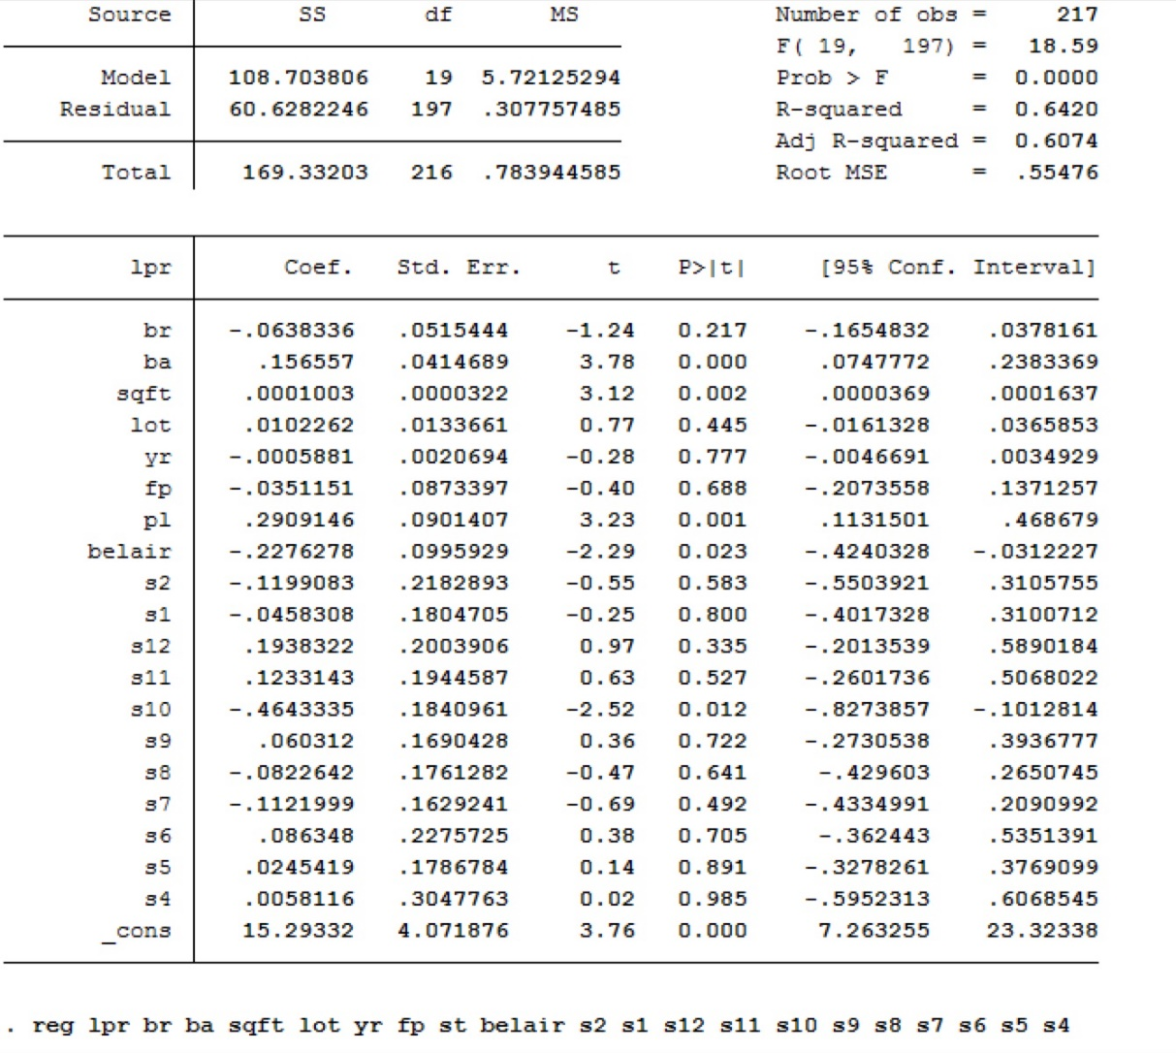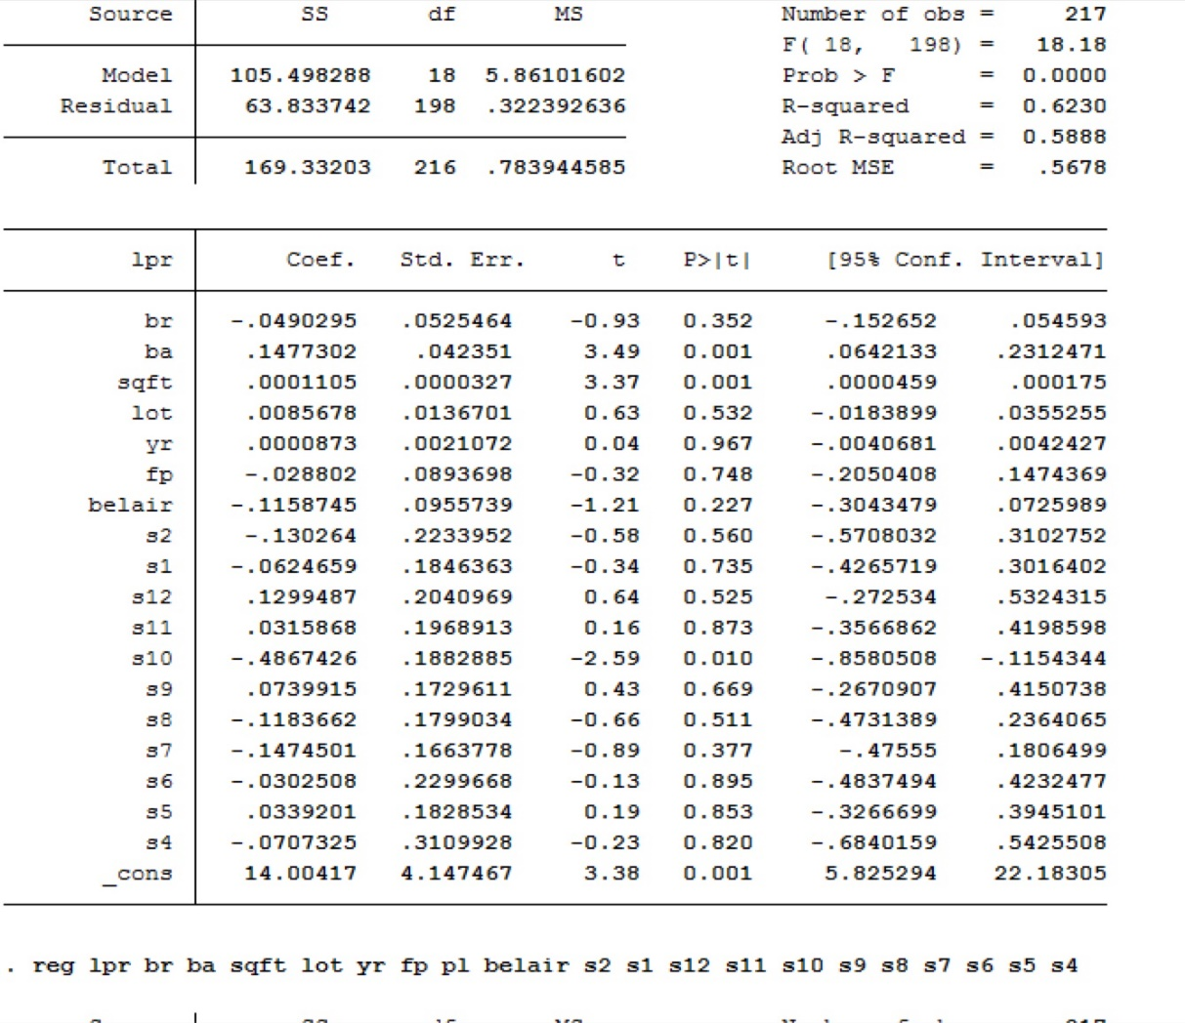

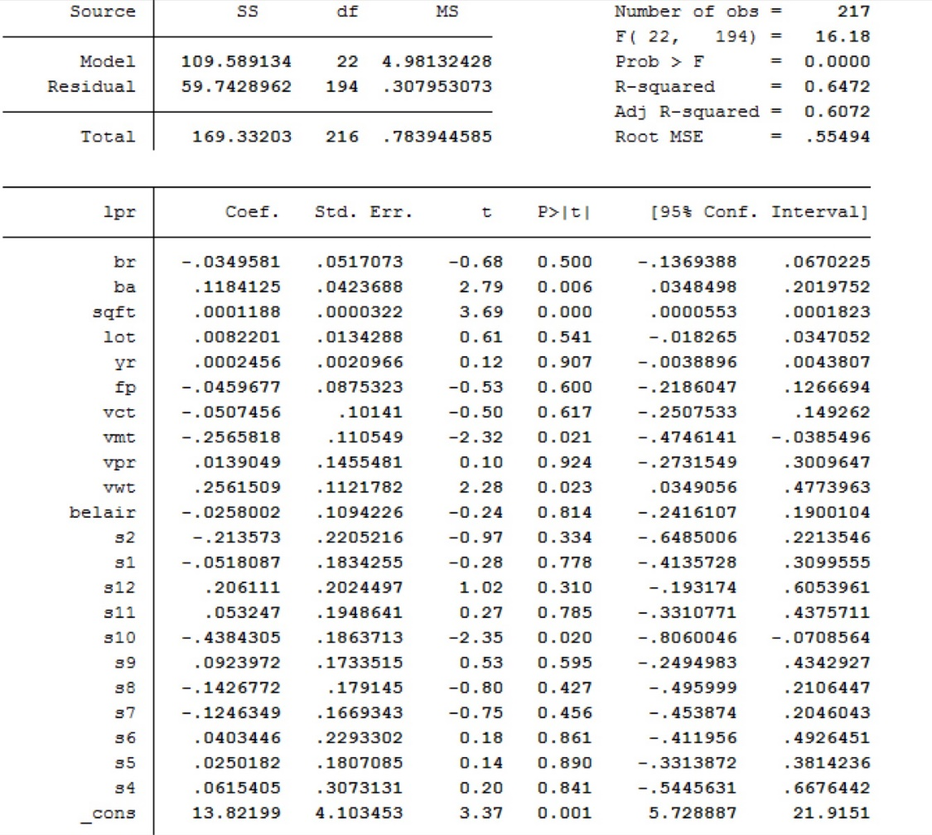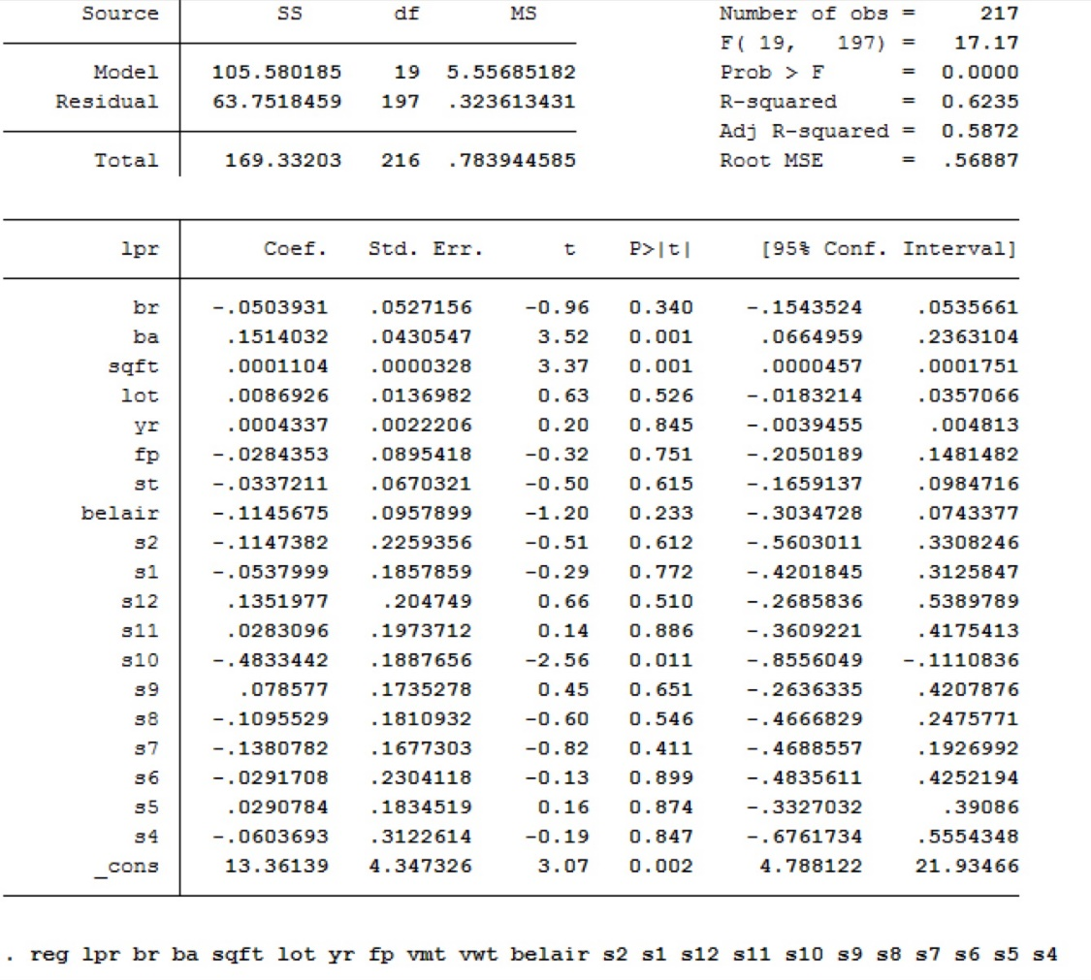

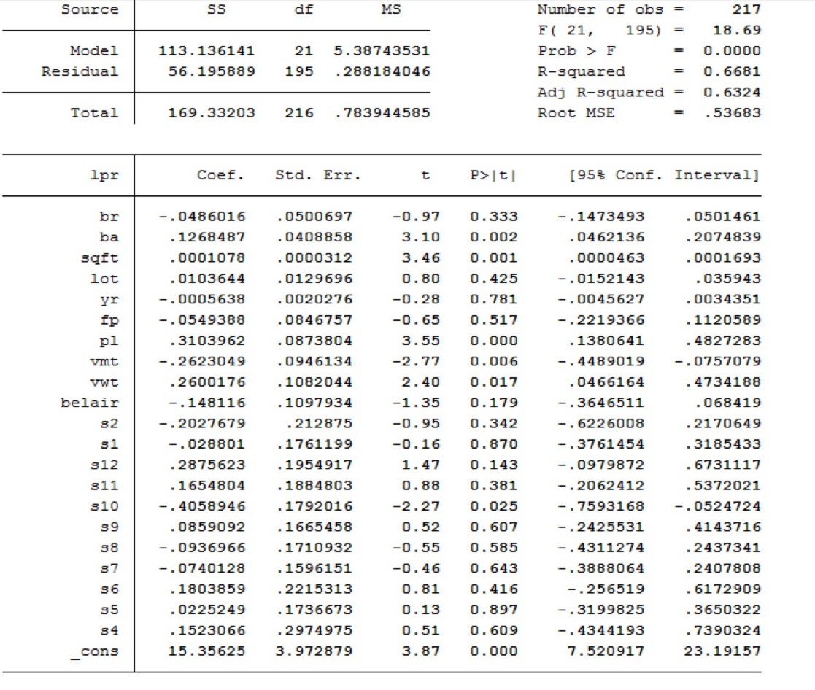

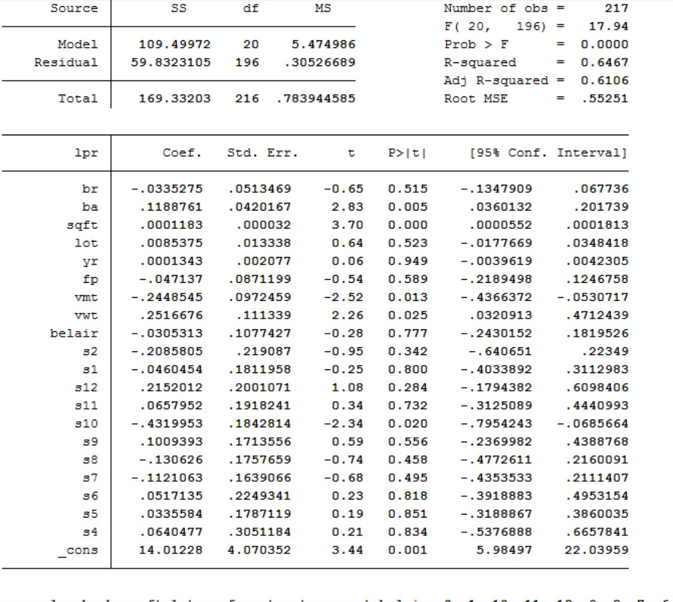The modified “base model” has an R-squared value of 0.6681, which is inline with hedonic house pricing models. Amount statistically significant variables, with other factors unchanged, an increase in the number of bathrooms, an increase in square footage, the existence of a pool, and a water view would increase the property price, while a mountain view would decrease the property price. Generally, the modified “base model” fits data fairly well, and is economically reasonable.

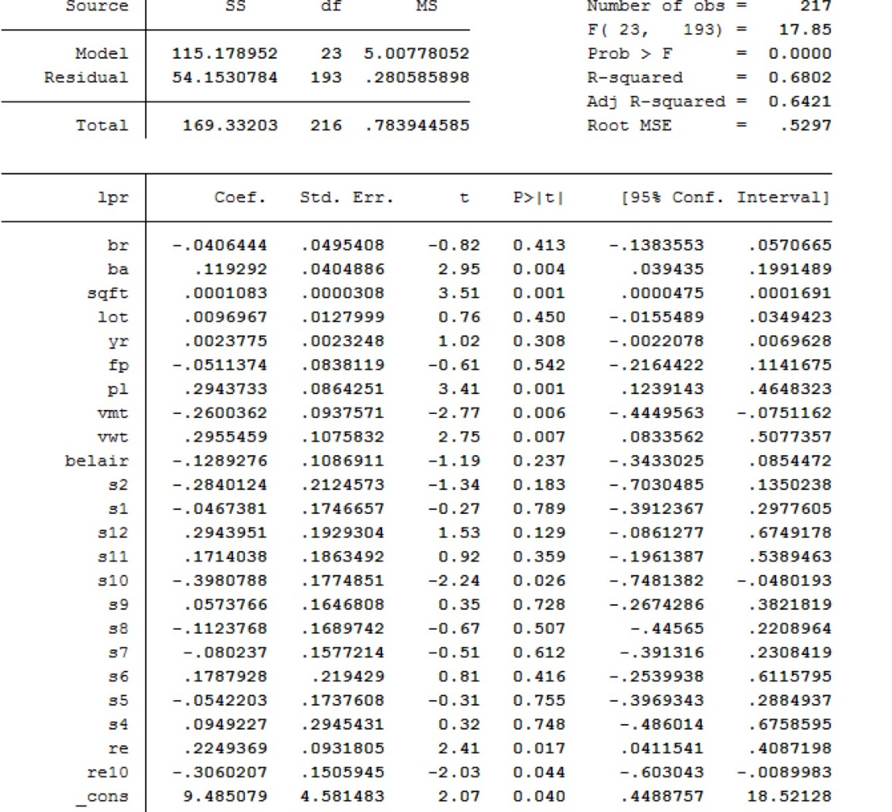Finally, remodeling dummy variables are added to this modified “base model”, to explain if, and how the status of remodeling affects property price.

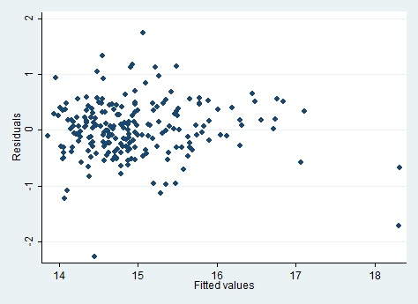

The R-squared value of 0.6802 evidences a well-fit hedonic house pricing model. Residual-versus-fitted value is also plotted, with no major issues identified.

Both remodeling dummy variables are statistically significant, indicating that remodeling does affect property price. With all other factors remain unchanged, the model predicts that an individual property would sell 0.2249369 more on the logarithm scale if it went through remodeling. However, the model also indicates that, if the last remodeling of an individual property occurred in the last ten years, the sales price of the property would decrease by 0.3060207 on the logarithm scale, offsetting the benefits of remodeling.

Summarizing the results, it could be concluded that, while generally remodeling would increases the property price, remodel activity conducted in the last ten years prior to the selling of the property would decrease the property price. In other words, it is evidential that remodeling is beneficial to the sales price of an individual property, yet such effect can only be observed in the long term.

**4 Suggestions**

Housing costs are the largest component of most household’s expenditure. So household make careful decisions about the cost, location, school nearby, amenities, and transportation method. They might have to make tradeoffs when faced with high housing costs: (1) spending a larger share of disposable income to buy a better house, (2) postponing or giving up homeownership, (3) living crowdedly, (4) commuting further to work places and schools, or (5) sometimes, choosing to live and work somewhere else. In terms of our report, households make renovation for their houses to make them easier to sell and accordingly raise rental and sales prices.

**4.1 Suggestions for government**

From the perspective of what governments can do to improve people’s living conditions, we believe the following suggestions are helpful.

1. Build more houses to boost housing supply, when the supply goes up, the prices of home prices will naturally go down.
2. Improve public transportation system such as the metro system in order to alleviate differences between suburb and urban areas. The price gap between these two areas will be narrowed.
3. Issue policies such as ceiling price to regulate real estate market, thus making houses more affordable. When government sets an upper limit of home prices, houses will become affordable for more people who otherwise cannot afford them. This policy is especially useful when there is such problem as real estate bubble. Government regulation and interference will help the real estate market function in a healthy way.

**4.2 Suggestions for home buyers**

1. House buyers need to educate themselves on market value and market trend. They need to get up to speed very quickly on market values, and know what the right decision is and when to make such decisions. The more educated house buyers are, the more likely they will respond to price changes and grasp the best opportunity to purchase a house.
2. Home purchase is often nothing but location, location, and location. For instance, whether a residential property is close to schools, whether it has water views, mountain views, or park views, and is criminal rate high or low in surrounding areas. All these factors influence property prices. Buyers need to have a clear picture of what they want, and compare different properties according to their preferences.
3. Data from our analysis shows that property prices in October tend to be lower than those in other months. Therefore, we suggest buyers to bear this difference in mind and include seasonal factor in the negotiation process with their agents, asking for a lower price in certain month.
4. According to our regression analysis, remodeling generally has a positive effect on home prices, but remodeling during the past ten years tends to lower house value. If buyers are very sensitive to prices, and prefer to have a house that is remodeled, we suggest him/her to buy one that was remodeled in the past ten years.

**4.3 Suggestions for home sellers**

1. Remodeling the kitchen before selling a home. It has been discovered that the kitchen, more than any other rooms, sells the home. Make sure to clean, polish, and fix such problems as leaky faucet, loose light fixture in the kitchen before showing it to any potential buyers. Given that remodeling increases a house’s value, we would also suggest sellers to remodel the kitchen before selling it.
2. Take advantage of features that add value to your house. Based on our analysis, such features as pool, number of bathrooms, and city views will add value to a property. Therefore, if your home has such advantages, make full use of it and try to sell it at a higher price.
3. Paint the rooms if possible before putting it on the market. If it is not profitable to repaint the entire house - to spend several thousand dollars on a massive paint job, which is not only labor consuming but also money consuming, it is suggested to repaint just one or two rooms with a bright color, white and off-white are good choices.

**5 Conclusion**

Based on empirical analysis, we have come to the following conclusions:

1. As predicted, remodeling is a significant factor in determining house prices. Given that the t-statistic of remodeling (re) is 2.41, and the t-statistic of remodeling in the past ten years (re10) is -2.03 (both greater than critical value), it is safe to say that remodeling is significant at the 95% confidence level.
2. Generally speaking, a house that has been remodeled in the past is more valuable than a house that has not. Given that the coefficient of remodeling is 0.2249, a house that has been remodeled is 22.49% more expensive than a house that has not. But if remodeling happens in the past 10 years, it tends to lower house value, which means a house that was remodeled in recent 10 years usually sell 30.6% less than those not.
3. Since the neighborhood dummy is insignificant (with a t-statistic of -1.19), property prices in Malibu and Bel Air behave similarly. In other words, the house prices in Malibu and Bel Air are not significantly different from each other, and both respond to remodeling in the same pattern.
4. As expected, square footage and the number of bathrooms positively relate to home prices.
5. Similar to other researches done in the past, our regression analysis also comes to the conclusion that the number of bedroom is negatively correlated with house prices, which is reasonable given that an increase in the total number of bedrooms usually leads to smaller area for each bedroom. But in our regression, this factor is insignificant.
6. There are eleven seasonal dummy variables in our regression analysis. Most of them turn out to be insignificant, but the seasonal dummy variable for October is significant with negative coefficients. This shows that home prices in October are generally lower than those in other months.

References

John P.Harding, (2007) Depreciation of housing capital, maintenance, and house price inflation: Estimates from a repeat sales model. Journal of Urban Economics 61 (2007) 193–217.

Delores A. Conway, David Dale Johnson, (1994) . Multivariate analysis of real estate prices. IMS Lecture Notes- Monograph Series.Vol.24.

A.C. Goodman, T.G. Thibodeau, (1995) Age-Related Heteroskedasticity in Hedonic House Price Equations. J. Housing Res., 6 (1995), pp. 25–42

Christian Janssen Bo Söderberg Julie Zhou, (2001),"Robust estimation of hedonic models of price and income for investment property", Journal of Property Investment & Finance, Vol. 19 Iss 4 pp. 342 - 360

Edmundas Kazimieras Zavadskas , Artūras Kaklauskas & Saulius Raslanas (2004) Evaluation of investments into housing renovation, International Journal of Strategic Property Management, 8:3, 177-190

McMillen, D. P. and Thorsnes, P. (2006), Housing Renovations and the Quantile Repeat-Sales Price Index. Real Estate Economics, 34: 567–584. doi: 10.1111/j.1540- 6229.2006.00179.x

Rappaport, Jordan. 2007. “A Guide to Aggregate House Price Measures,” Federal Reserve Bank of Kansas City Economic Review, vol. 92, no. 2, pp. 41–72.

Mats Wilhelmsson,2008. House price depreciation rates and level of maintenance. Journal of Housing Economics 17 (2008) 88–101

Bo Huang , Bo Wu & Michael Barry (2010) Geographically and temporally weighted regression for modeling spatio-temporal variation in house prices, International Journal of Geographical Information Science, 24:3, 383-401